**NCP Class Assignment 3**

31/07/2020

Ragul S V

CB.EN.U4CSE17348

**Code:**

**Table.html**

<!DOCTYPE html>

<html>

<head>

<title>CSS Table</title>

<link rel="stylesheet" type="text/css" href="table.css">

</head>

<body>

<div class="center">

<h1>HTML td Background with CSS</h1>

<table>

<tr>

<th>Dedicated Hosting</th>

<th>VPS Hosting</th>

<th>Sharing Hosting</th>

<th>Reseller Hosting</th>

</tr>

<tr>

<td>$200/Month</td>

<td>$100/Month</td>

<td>$20/Month</td>

<td>$50/Month</td>

</tr>

<tr>

<td>Free Domain</td>

<td>Free Domain</td>

<td>Free Domain</td>

<td>Free Domain</td>

</tr>

<tr>

<td>2GB DDR2</td>

<td>20GB Disk Space</td>

<td>Unlimited Email</td>

<td>Unlimited Email</td>

</tr>

</table>

<div>

</body>

</html>

**Table.CSS**

body{

padding:0px;

margin:0px;

}

h1{

color:#00ACC1;

}

table{

width:50%;

margin:auto;

background-color:#E0E0E0;

text-align: center;

border-collapse: collapse;

}

table tr td,th{

border:solid 6px #BDBDBD;

padding:10px;

}

.center{

text-align:center;

margin-top:100px;

}

table th:nth-child(1),td:nth-child(1){

background-color: #00695C;

}

table th:nth-child(2),td:nth-child(2){

background-color: #689F38;

}

table th:nth-child(3),td:nth-child(3){

background-color: #9CCC65;

}

table th:nth-child(4),td:nth-child(4){

background-color: #D4E157;

}

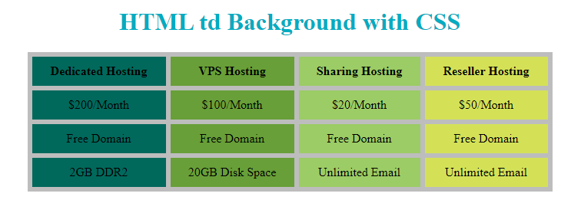**Screenshot:**